3 The OpenAI API

This chapter covers
- Installing the OpenAI client
- Invoking GPT using Python
- Configuration parameters
Please ignore grammar errors and typos. What you see is a raw manuscript; it has not been copyedited.
Language models are often used as a sub-function within a complex data processing pipeline. For instance, you might want to iterate over text documents in a repository, extract structured information from each (that part uses a language model), then filter the resulting data and insert remaining entries into a database, before visualizing aggregates. Python is a popular programming language among data scientists and is often used to implement pipelines such as the one above. But how can we integrate calls to a language model into a Python program?
In this chapter, we will discuss OpenAI’s Python API. This API enables you to use OpenAI’s GPT models from inside of your Python code. We will go over the setup of this library, learn how to select and call GPT models and discuss about various tuning options. While this chapter focuses on OpenAI’s Python API, other providers such as AI21, Anthropic, and Cohere have released Python APIs with similar functionality. After familiarizing yourself with the OpenAI API, you should be able to switch to any of the other libraries with moderate learning overheads.

3.1 Prerequisites
First of all, let’s make sure that we have the right environment for running the code samples discussed in the following. We will be using the Python programming language so, first of all, make sure that Python is installed. To do so, open a Terminal and enter the following command (this command should work for Linux, Mac OS X, as well as Windows terminals):
python --version
copy
If Python is installed on your system, you should see a version number in reply (e.g., “Python 3.8.5”). If not, you will get an error message. For the following examples, you will need at least Python 3.7.1 (or a later version). If Python is not installed on your system, or if your version is below the required one, visit https://www.python.org/, click on “Downloads”, and follow the instructions to install Python. Along with Python, you may want to install an Integrated Development Environment (IDE). For instance, PyCharm¹ and PyDev² are some of the many IDEs available for Python.
Along with Python, we will need Pip, a package-management system used to install Python packages (the OpenAI client comes in the form of such a package). For recent Python versions (which you will need in any case), this program is already installed by default. Nevertheless, it can’t hurt to make sure:
pip --version
copy
Again, you should see a version number if everything is installed properly. Let’s make sure that pip is up to date. The following command should work on Linux, Mac OS X, and Windows as well:
python -m pip install --upgrade pip
copy
That’s it! Your system is ready to install the OpenAI Python client.

Figure 3.1 The Google Colab platform can be used to run the following examples.
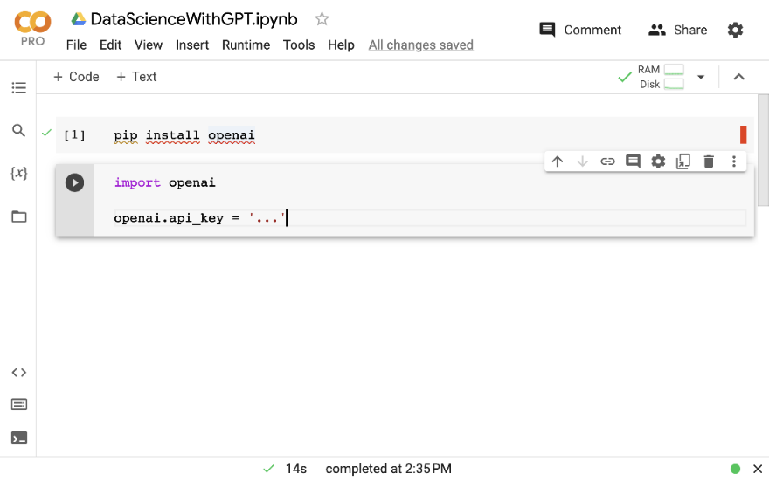

Up - As a matter of convenience, would help beginners to show code to check Python version.

What if it doesn’t work?
Don’t panic! If any of the aforementioned steps fail, you may not be able to execute the following code on your local machine. However, as long as you have Web access, you can simply use a Cloud platform instead. For instance, the Google Colab platform, accessible at https://colab.research.google.com/, enables you to create notebooks that are able to execute all of the following examples. Figure 3.1 shows the interface, after creating a cell installing the OpenAI client (top cell, see explanations in the following section) and the start of a corresponding Python program (lower cell, see the following sections for further explanations).
Any comments on section 3.1 Prerequisites?

Up - As a matter of convenience, would help beginners to show code to check Python version.

3.2 Setting up the OpenAI client
Time to start using GPT like a pro! While the Web interface, discussed in , is useful for conversations and for trying out new prompts, it is not suitable for implementing complex data processing pipelines. For that, OpenAI’s Python API is a much better choice, enabling you to integrate calls to language models into arbitrary Python programs. First of all, let’s install the corresponding library. Enter the following command into a terminal:
pip install openai==1.29
copy

Can I use a different library version?
You might have noticed the reference to a specific version (Version 1.29) of the OpenAI library. The code presented in this and the following chapters has been tested with this version. As the syntax differs slightly across different library versions (unless you are willing to adapt the code), make sure to install this precise version.

Figure 3.2 Managing secret keys for accessing the OpenAI API.
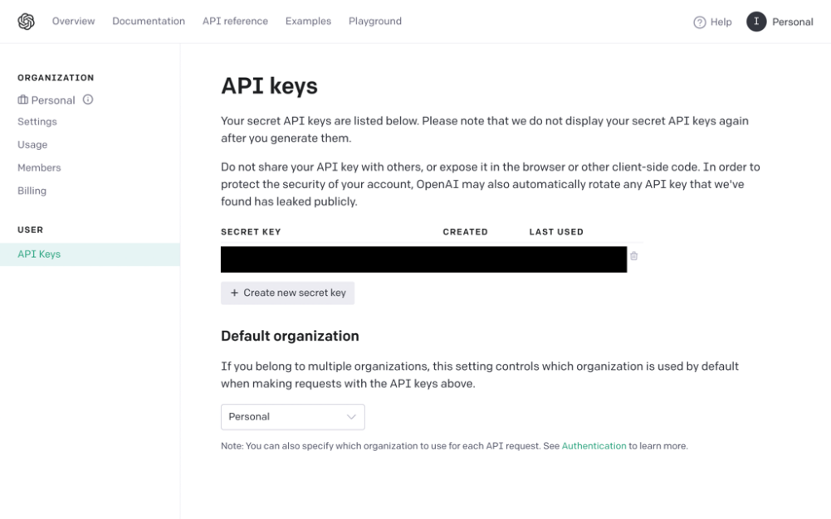\
Up -Understood.
Every time we use the OpenAI client, we need to provide a key giving us access to the OpenAI models (e.g., this is required for billing purposes). If you have not yet created an OpenAI account, go to the URL https://platform.openai.com/, click on “Sign Up”, and follow the instructions. If you have an account but are not currently logged in, provide your account credentials instead. After that, in case you haven’t done so yet, it is time to generate your secret key.
Go to https://platform.openai.com/account/api-keys. You should see the Web site shown in Figure 3.2. Click on the “Create new secret key” button. The interface will now show a text string, representing the key. Make sure to copy and store that key! You will not be able to retrieve the full key again after closing the corresponding window.
Whenever we use the Python API, we need to provide our secret key to link our requests to the appropriate account. The easiest way of doing that is to store the secret key in an environment variable named OPENAI_API_KEY. OpenAI will automatically extract the key from that variable if it exists. The precise command used to set environment variables depends on the operating system. E.g., the following command works for Linux and Mac OS (replace the three dots with your key):
export OPENAI_API_KEY=...
copy
Alternatively, you can set the key on a per-invocation level by prefixing your calls to Python with the corresponding assignments. E.g., use the following command to call the listing presented in the next section while setting the key at the same time (again, substitute the three dots with your key):
OPENAI_API_KEY=... python listing1.py
copy
We are now ready to start calling GPT via the Python API.
Any comments on section 3.2 Setting up the OpenAI client?

Up -Understood.

3.3 Listing available models
First of all, we will use the Python client to retrieve a list of OpenAI models that are available for use. Listing 3.1 shows the corresponding Python code. First, we import the OpenAI library . Then, we create a client object, enabling us to access API functions . Next, we query OpenAI for the available models and finally print out the result .

Listing 3.1 Listing available OpenAI models
import openai
client = openai.OpenAI()

models = client.models.list()

for model in models.data:
print(model)
copy
Up – Executed successfully.
You should see a results similar to the following:
Model(id='dall-e-3', created=1698785189,
object='model', owned_by='system')
Model(id='whisper-1', created=1677532384,
object='model', owned_by='openai-internal')
Model(id='gpt-4o-2024-05-13', created=1715368132,
object='model', owned_by='system')
Model(id='davinci-002', created=1692634301,
object='model', owned_by='system')
Model(id='gpt-4o', created=1715367049,
object='model', owned_by='system')
...

Model(id='curie:ft-personal-2022-01-10-16-52-53',
created=1641833573, object='model', owned_by='trummerlab')
Model(id='davinci:ft-personal-2022-01-13-19-59-51',
created=1642103991, object='model', owned_by='trummerlab')
Model(id='ft:gpt-3.5-turbo-0613:trummerlab::8qlJH6bV',
created=1707585607, object='model', owned_by='trummerlab')
...
copy
Each model is described by an ID (e.g., gpt-4o ). This is the ID we will use to tell OpenAI which model we want to use to process our requests. Besides the ID, each model comes with a creation timestamp, and with information on model ownership (field owned_by). In most cases, models are owned by OpenAI (marked, e.g., as system or openai-internal). In some cases, however, models are owned by trummerlab , the name of the account used for executing the code. Such models are not publicly accessible but private to the owning account. They are created by a process called fine-tuning from the publicly available base models.

What is fine-tuning?
By default, language models such as GPT are trained to be versatile, meaning they can, in principle, perform any task. However, sometimes, we don’t want a model that is versatile but rather a model that does very well on one specific task! Fine-tuning enables us to specialize a model for a task we care about. We use fine-tuning in more detail in .
Any comments on section 3.3 Listing available models?

Up -Understood.

3.4 Making GPT tell us a story
Alright, we can see which models are available. But how can we actually use them? That’s what we will discuss in this section, focusing on a basic task that is nevertheless applicable in a variety of use cases: text completion!
Let’s use GPT for text completion! Here, the goal is to write a continuation for a given prompt (i.e., a text snippet). As the prompt may contain the description of a task (in natural language), thereby nudging the model to provide a solution to that task in the prompt completion, text completion is a powerful feature that is applicable to solve a variety of tasks. Many of the approaches presented in this and later chapters are, ultimately, based on text completion.
Whenever we use OpenAI’s API, our first step is to import the OpenAI library and create a client object:

import openai

client = openai.OpenAI()
copy
Now, we can use the client object to invoke models for tasks such as text completion. More precisely, we will use the GPT-4O model in the following. GPT-4O is one of OpenAI’s chat models. Such models support multi-turn interactions with users, i.e., a dialogue such as the one we had with GPT-4O in the last chapter. We will focus on chat models since most of OpenAI’s recently released models (including GPT-3.5, GPT-4, and GPT-4O) fall into this category.
When using chat models for text completion, the input is described as a list of previously exchanged messages. In the Python API, each message is represented as a dictionary with (at least) two fields:
Possible values for the role parameter are the following: user, system, and assistant. Here, user identifies a message as written by the user. This is the only role that we need for our simple example (since the model should solve a task described by the user). The assistant role designates messages generated previously by the assistant (i.e., by the model itself). This is useful when specifying a history of messages, describing a back-and-forth between model and user (which is what you typically have when chatting with ChatGPT). The system role is used to specify messages meant to influence the behavior of the model. Typically, this is done in a single message, at the very beginning of the messages list. For instance, a classical command passed as system message is “You are a helpful assistant.”. However, in some cases, you may want to be more specific, e.g., “You are a helpful assistant translating questions into SQL queries.”. Adding specific system messages can improve performance but is not strictly required and we won’t explore it here.
For our current problem, a single input message should be sufficient:
[{
'role':'user',
'content':'Tell me a story!'
}]
copy
This list contains only a single message, marked as originating from the user and consisting of a simple instruction (“Tell me a story!”). The following code generates a completion for this input message and stores it in the result variable:
result = client.chat.completions.create(
model='gpt-4o',

messages=[{
'role':'user',
'content':'Tell me a story!'
}])
copy
We refer to the chat.completions endpoint as we’re using a chat model for text completion. Also, we specify the ID of the model we want to use (gpt-4o), and the (singleton) list of input messages . Listing 3.2 shows the complete code for generating stories with GPT. After importing the OpenAI library and creating the client object , it performs text completion with the GPT-4O model and the appropriate instructions .

Listing 3.2 Using GPT for text completion

import openai

client = openai.OpenAI()

result = client.chat.completions.create(
model='gpt-4o',

messages=[{
'role':'user',
'content':'Tell me a story!'
}])
print(result)
copy

Up - Understood. Ran without error.
Running the code should produce a result such as the following (your precise story may differ due to randomization):
ChatCompletion(
id='chatcmpl-9YKmJCE8SITsKyI557T8KTuX3IxWN',

choices=[
Choice(
finish_reason='stop',
index=0,
logprobs=None,

message=ChatCompletionMessage(
content="Of course! Here’s a story that ... ",
role='assistant',
function_call=None,
tool_calls=None)
)
],
created=1717970051,
model='gpt-4o-2024-05-13',
object='chat.completion',
system_fingerprint='fp_319be4768e',

usage=CompletionUsage(
completion_tokens=810,
prompt_tokens=12,
total_tokens=822
)
)
copy
Let’s discuss the different components of that result. First of all, we have a list of completion alternatives (objects of type Choice). In our case, that list contains only a single entry. This is the default behavior, while we could ask for multiple alternative completions by setting the right configuration parameters (discussed in the next subsection). The finish_reason flag indicates for each completion the reason to stop generating. This could be due to reaching a length limit on generated text (we discuss how to set such limits in the next section) or due to reaching a stop token (i.e., one out of a list of tokens that indicate termination). The value stop indicates that the language model was able to generate complete output (as opposed to reaching a length limit). The actual message content is abbreviated and, in all likelihood, you will see different stories if you invoke the code repeatedly.
Besides the completions themselves, the result contains meta-data and usage statistics . More precisely, we find values for the following properties:
Why would we care about the number of tokens? Because pricing for most OpenAI models is proportional to the number of tokens read and generated. For instance, at the time of writing, using GPT-4O costs USD 5 per million tokens read and USD 15 per million tokens generated. Note the difference in pricing between tokens read and generated. Typically, as in this case, generating tokens is more expensive than reading tokens. The pricing depends not only on the number of tokens but also on the model used. E.g., replacing GPT-4O with the GPT-3.5 Turbo model (a slightly less powerful GPT version) cuts cost by a factor of ten. Before analyzing large amounts of data with language models, make sure to choose the appropriate model size for your wallet.
Any comments on section 3.4 Making GPT tell us a story?
Down - My result did not look similar to example. My result was unformatted, and it prompted me for more details:

ChatCompletion(id='chatcmpl-A8JgxsV4Vz4Y12XoM8QUkVZvuWCV4', choices=[Choice(finish_reason='stop', index=0, logprobs=None, message=ChatCompletionMessage(content=

'Sure! What kind of story would you like to hear?
Do you have a preference for genre, setting, or characters?'

, role='assistant', function_call=None, tool_calls=None, refusal=None))], created=1726545683, model='gpt-4o-2024-05-13', object='chat.completion', system_fingerprint='fp_a5d11b2ef2', usage=CompletionUsage(completion_tokens=25, prompt_tokens=12, total_tokens=37, completion_tokens_details={'reasoning_tokens': 0}))

3.5 Customizing text generation
So far, we have been using the default settings for all parameters of the text completion function used in Listing 3.2 (with the exception of the model and messages parameters). In the following, we will have a look at some of the most useful parameters to configure. A list of parameters, together with a description, follows.
Ok, we have discussed the most important parameters for data analysis purposes. You can use each of them when requesting a completion from GPT. Note that there are more parameters, beyond the ones mentioned above. You find a full list of parameters in the OpenAI API reference documentation³.

Listing 3.3 Using GPT for text completion with custom parameter settings

import openai

client = openai.OpenAI()

result = client.chat.completions.create(
model='gpt-4o',

messages=[{
'role':'user',
'content':'Tell me a story!'
}],
max_tokens=512,
stop='happily ever after',
temperature=1,
presence_penalty=0.5,
logit_bias={14844:-100})
print(result.choices[0].message.content)
copy

? - Not sure how added parameters gave my result.
Finally, let’s try out some of the aforementioned parameters in our code. Listing 3.3 shows code prompting GPT to write a story, this time using some of the parameters discussed above to customize text completion. First, to avoid getting a lengthy story, we set the maximal number of tokens to 512. This should suffice for a few paragraphs of text. To avoid generating more content than necessary (perhaps, new instructions, followed by a corresponding solution), we define a stopping criterion as well: “happily ever after”. We do so, hoping that any reasonable story will, of course, end with the popular expression “and they lived happily ever after”. Certainly, this assumption is simplifying. Next, we set the temperature to one, thereby allowing for a certain degree of randomization. Having an overly repetitive story is boring, therefore we set a positive presence penalty (presence_penalty=0.5), discouraging GPT from reusing the same tokens. Finally, we don’t want a scary story (perhaps we want to read it to our kids) and therefore penalize the word “dragon” (with token ID 14844).
Let’s see what we get! For instance, in a sample invocation, GPT generates the following story: “Once upon a time, in a quaint village nestled between rolling hills and dense forests, there lived a girl named Elara. She was known for her curiosity and adventurous spirit, traits that often led her to explore the uncharted parts of her village. One crisp autumn morning, Elara decided to venture into the Whispering Woods, a place shrouded in mystery and legend. The villagers often spoke of the woods as a place where magic lingered, but also one that nobody dared to enter beyond the edge. Equipped with her trusty satchel and a heart full of excitement, Elara set off with the sunrise. As she walked deeper into the woods, the whispers of rustling leaves seemed to greet her, and she felt an odd sense of familiarity. She wandered through thickets and climbed over fallen logs until she stumbled upon a hidden grove, bathed in shimmering light. In the center of the grove stood an ancient tree with silvery leaves, its trunk twisted like spiraling tendrils of smoke. Elara was mesmerized; it looked unlike any tree she had ever seen. She approached it cautiously and noticed a small, ornate chest nestled among its roots. Her heart racing, Elara opened the chest and found inside a delicate, golden locket. As soon as she touched it, the forest seemed to come alive. The whispers grew louder, forming words that she could understand. “Brave heart, you have found the Locket of Eternia,” the voice murmured. “It grants the bearer one wish.” Elara’s mind raced with possibilities, but she knew what her heart desired most: to bring joy and prosperity to her beloved village. Clutching the locket, she whispered her wish. In an instant, a warm glow enveloped her, and she felt a surge of energy. The grove shimmered momentarily and then returned to its tranquil stillness. Elara knew something extraordinary had happened. As she returned home, she noticed subtle changes—the crops seemed more vibrant, the animals healthier and the village air filled with a sense of contentment. The villagers welcomed her back, their faces glowing with happiness. Elara never revealed the secret of the Whispering Woods or the Locket of Eternia to anyone. She simply smiled whenever anyone commented on the newfound prosperity of the village. She knew that sometimes, the greatest magic lies not in what is seen, but in the courage to follow one’s heart. And so, Elara’s village thrived, becoming a beacon of joy and harmony. All because one brave girl dared to listen to the whispers of the woods. And she lived ”. Happily ever after! It turns out our termination criterion, the expression “happily ever after”, was indeed used at the end of the story (and is therefore omitted in the output returned by GPT). Try out a few more parameter settings and see how the result changes as a function of the configuration. You may also consider trying a different start of a story or a different task altogether.
Any comments on section 3.5 Customizing text generation?

Down - My result did not look similar to example. My result was unformatted, and it prompted me for more details:

“Certainly! What genre or type of story would you like to hear? Fantasy, adventure, mystery, or perhaps something else?”

3.6 Summary
- You can use OpenAI’s language models via a Python API.
- Other providers offer similar Python APIs to OpenAI.
- To use OpenAI’s library, create a client object.
- Most of OpenAI’s most recently released models are chat models.
- Chat models are optimized for multi-turn interactions with users.
- Chat models take a list of prior messages as input for completion.
- Each chat message is characterized by content and a role.
- Roles can be one of user, assistant, and system.
- Use chat models for text completion via the chat.completions endpoint.
- You can configure models using various parameters.
- The temperature parameter chooses the degree of randomization.
- The max_tokens parameter limits the number of tokens generated.
- Alternatively, stop allows defining phrases that stop text generation.
- You can penalize or encourage specific tokens via logit_bias.
¹ https://www.jetbrains.com/pycharm/↩︎
² https://www.pydev.org/↩︎
³ https://platform.openai.com/docs/api-reference/completions↩︎
What did you think of this chapter?
hide feedback

1
How many stars would you give this chapter?

3

2
What is your overall impression of this chapter?

Good instructions for preparing environment. But getting responses drastically different from those in the text is discouraging.

sitemap
Prev Chapter
Next Chapter
Select a piece of text to create a new review comment
Up next...
4 Analyzing text data
- Classifying text
- Extracting information
- Clustering documents

